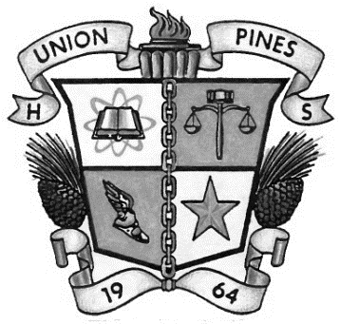

Union Pines High School

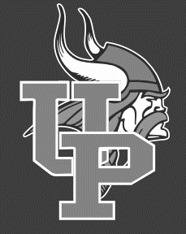

1981 Union Church Road

Cameron, NC 28326

**2020-2021 School Profile**

**Community and School**

Union Pines High School is located in a beautiful rural setting in Moore County. UPHS opened its doors in 1964 and is located in eastern Moore County. The name was chosen because the school is located directly across from the historic Union Presbyterian Church. The campus is on the site of the old Union Home Academy which served students during the 1800’s.

UPHS is a comprehensive 9-12 public school on a traditional calendar. Students participate in a modified block schedule mainly consisting of four courses per semester. The average class size is 28. The 1400 students that attend UPHS are known for their outstanding academics, athletics and diverse talents inside and outside of the classroom. UPHS has some of the brightest students in Moore County with over 9.5 million dollars in scholarships awarded this year. Of the 2020 graduates, 44% will be attending community college, which included 174 seniors achieving Sandhills Promise Scholarships and 222 seniors earned 1178 college credits while in high school. In addition, 39% of seniors left to seek 4-year college degrees. The Vikings are the pride of the community and an example of excellence in Moore County.

In partnership with Sandhills Community College and the Career and College Promise Program, students have the opportunity to dual enroll in college courses through a variety of venues their Junior/Senior years. Courses offered through NC Virtual Public School help students with SAT/ACT preparation as well as supplement the traditional course offerings. GradPoint Distance learning is also available for remediation. In addition, UPHS integrates technology into the daily program of instruction utilizing Chromebooks for every student, Smart Board equipped classrooms, computer pods, teacher stations, mobile laptop labs, three multi-media presentation stations, i 3-D computer station, classroom web pages, and internet access and network accounts for all staff and students. Furthermore, there are a full range of exceptional education services provided through study labs and continuous teacher/parent collaboration as well as support for students with limited English proficiency.

Students excel in theater, choral, visual arts, orchestra and band. The arts department has an excellent reputation for delighting and awing the community through marching band performances, visual arts shows, the annual musical and concerts. The marching band participates in fall competitions across the region bringing home numerous awards. The growing athletics program is known as being competitive in the 3A conference. Twenty-nine athletic teams encourage student participation; the Vikings are well-represented in many conference and state championships. The Navy Junior Reserve Officer Training Corps (NJROTC) has over 100 cadets. Outstanding leadership opportunities are available including participation in academic, drill, and physical fitness meets. The NJROTC Unit has produced 23 military academy appointments and numerous university scholarships.

**Contact Information**

Principal: Andy McCormick

School Counselors:

Assistant Principals: Jerid Cassady Polly Robinson 9th-12th A-F

Janna Kennedy Janice French 9th-12th G-N Hawhana Locklear Ashley Dull 9th-12th O-Z

Career and College Promise Counselor: Stacy Patterson Registrar/Guidance Secretary: Mary Beth Thomas

Career Development Coordinator: Brittni Sanborn

Athletic Director: Chad Hill At-Risk Coordinator/Graduation Coach: Scott Absher

Scholarship Coordinator: Janet Caddell

Main Office phone: (910) 947-5511 Website [www.ncmcs.org/up](http://www.ncmcs.org/up)

Fax: (910) 947-5117 CEEB Code: 340595

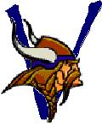

**Sports Offered**

Football, Volleyball, Tennis, Soccer, Golf, Cross Country, Track and Field, Basketball, Swimming, Wrestling, Softball, Baseball, Cheerleading, and Lacrosse.

**Clubs and Activities**

Book Club, Cyber Patriots, DECA, Drone Club, Fellowship of Christian Athletes(FCA), Fishing Club, French Club, Future Business Leaders of America(FBLA), Future Farmers of America(FFA), Future Teachers of America(FTA), Gaming Club, Health Occupations Students of America(HOSA), Interact Club(Rotary), Key Club(Kiwanis), Leo Club(Lions), National Art Honor Society(NAHS), National Honor Society(NHS), National Technical Honor Society(NTHS), Robotics Club, Science Olympiad, Skills USA Club, Spirit Club, Student Athlete Advisory, Speech and Debate Team, Student Government, Student 2 Student(S2S), Thespian Society, Tri-M Music Honor Society.

Union Pines High School

**Scholarships**

The Senior Class of 2019 earned a total of over $9.5 million dollars in scholarships. Senior scholarships are posted monthly in a senior newsletter on the Union Pines School Counseling Webpage. Seniors may also pick up a copy of scholarship information in the Scholarship Office.

**Grading System and G.P.A. Calculation**

Grading is based on a 4.0 scale. Honors courses receive .5 (1/2) extra quality point. AP and SCC CCP courses receive 1 extra quality point. All courses are included in rank. Class rank will be determined by ranking all students numerically by weighted GPA. Class rank will be calculated at the end of each semester.

Grading Scale: A 90-100 (4.0), B 80-89 (3.0), C 70-79 (2.0), D 60-69 (1.0), F 0-59 (0.0)

**Honors Courses**

Students can enroll in honors sections of English, Math 1. Math 2, Math 3, Pre-Calculus, Earth Science, Biology, Physics, Chemistry, World History, US History, Civics and Economics, as well as honors sections of Band, Vocal Music, Orchestra, Visual Arts, Theater Arts, and many Career Technical Education courses. Honors credit is awarded for additional courses in Spanish III, IV, and French III, IV.

**Advanced Placement Courses**

Union Pines High School celebrated 13 students qualifying as AP Scholars in 2019-20. The AP courses offered at Union Pines High School are Biology, Calculus AB, Calculus BC, English Language and Composition, English Literature and Composition, Human Geography, Spanish Language, Studio Art, United States Government and Politics, and United States History, in addition to online NCVPS AP course offerings.

**ACT Results**

Year Participation Avg Composite English Math

2018-19 100% 19.6 18.0 18.9

2017-18 100% 19.5 18.1 19.7

2016-17 100% 18.7 17.8 18.9

2015-16 100% 19.0 17.8 19.1

**SAT Results**

Year Participation Avg CR and Math

2018-19 30% 1154

2017-18 22% 1145

2016-17 36% 1160

**Graduation Requirements**

All students are recommended to graduate with 28 credits/ 22 minimum. Specific course credit requirements include English (4), Math (4 including Math 1,2,3 and an Advanced Math), Science (3 including Earth Science, Biology, and a Physical Science), Social Studies (4 including World History, Civics, Economics and Personal Finance, American History), Physical Education/Health (1 for grade 9), Foreign Language (2 for a 4 Year University), Career/Technical (4 for a CTE concentration), and Elective Credits (10 or 12).